Californian inspired salad

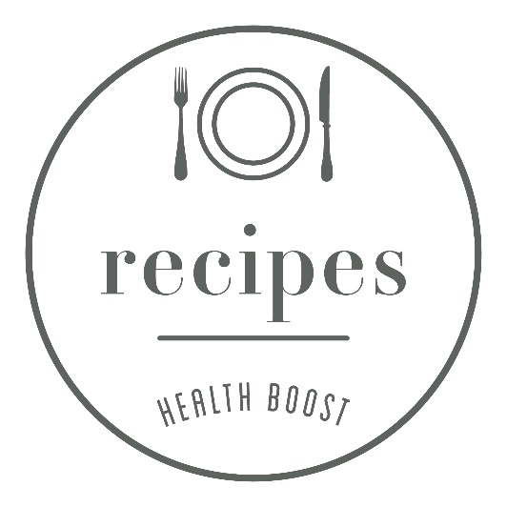
After my recent trip to California, where I had lots of salads, I was inspired to make my own Californian salad. I have used ingredients that were used in many of the salads I tried - kale, quinoa, feta, avocado and almonds. It seemed typical of many of the salads to contain fruit. I am not a fan of fruit in my salad so instead chose to add lemon to a dressing and include some fruit that way!

INGREDIENTS
serves 3
200g cooked quinoa
2 large handfuls of kale
1 large carrot
1 large beetroot
1 large avocado
100g feta cheese
10 cherry tomatoes
25 almonds
juice of 1 lemon
6 tablespoon of extra virgin olive oil
black pepper

METHOD
- Place the cooked quinoa in the salad bowl.
- Shred the kale and add to the salad bowl.
- Grate the beetroot and carrot. This is easiest in a food processor.
- Slice and cube the avocado and add to the bowl.
- Cube the feta, slice the tomatoes and add both of these.
- Chop the almonds and also add these to the bowl.
- Lastly place the lemon juice, extra virgin olive oil and black pepper in a jar and shake to combine and pour over the salad.

THE HEALTH BOOST TIP
A bright colourful salad that contains a ‘rainbow’ of different colour vegetables. We like to pack our salads with vegetables in a range of colour - not only do you get a wide range of vitamins and minerals, but also phytonutrients.
When you cook the quinoa why not cook double to use for another day? It keeps well in the fridge for 3-4 days or can be frozen. When grating carrot and beetroot I also tend to grate up more than I need to serve in a salad another day.

